Data Collection and Manipulation

# Simulation Parameters and Timeline for Analysis

* Objective: Simulating wine production to forecast and satisfy future demand.
* Wine Example: For Red Wine 1: Pinot Noir 1er Cru.
* Production Time: Takes 18 months from the end of harvesting to be ready for consumption.
* Simulation Start Yea: 2020.
* First Grape Harvest: September 2024.
* Harvest Duration: One month.
* Subsequent Harvests: Annually in September (e.g., September 2025, September 2026, etc.).

# Production Details

## Harvesting and Availability (Example for Red Wine 1)

* First Harvest:
  + Date: September 2024
  + Process: Grapes are harvested within this month and immediately processed to begin fermentation.
  + Grape Processing Completion: October 2024
* Aging:
  + Start: October 2024, immediately after processing.
  + Duration: 18 months in oak barrels to develop full flavors and proper aging.
  + Completion: March 2026
  + Ready to Satisfy Demand from April 2026

## Market Readiness and Demand Fulfillment:

* First Availability for Sale:
  + Date: March 2026
  + Context: After the aging process is complete, the wine is bottled and prepared for distribution.
* Demand Satisfaction Period:
  + From: April 2026
  + To: March 2027
  + Details: This batch will cover market demands for a full year, ensuring continuous supply until the next batch is ready.

### Subsequent Batches and Annual Cycle:

* Annual Harvesting:
  + Schedule: Every September (e.g., 2025, 2026, etc.)
  + Similar Process: Follows the first harvest's timeline with grapes harvested and processed in September, aged for 18 months.
* Readiness and Distribution:
  + Following Batch Availability:
    - Example for 2025 Harvest:
      * Harvest Month: September 2025
      * Market Ready by: March 2027 (after 18 months of aging)
      * Coverage Period: April 2027 to March 2028
* Continuous Supply:
  + Each batch is precisely timed to ensure that as one batch’s demand satisfaction period concludes, the next batch is ready for market introduction.

### Key Notes on Demand Satisfaction:

* Strategy: Each annual batch is designed to meet customer demand efficiently for the entire year following its release. This consistent supply chain management ensures no gaps in market availability, maintaining customer satisfaction and operational excellence.
* Implementation: The backtracking flow utilized in the simulation models guarantees that all necessary resources (e.g., oak barrels, harvested grapes) are accounted for in advance, optimizing the production process against forecasted demand patterns.

## Backtracking Analysis

Utilized to calculate the necessary resources retrospectively based on demand forecasts.

Resources Analyzed:

* Oak Barrels: Number required for aging the wines per batch.
* Grape Tonnes: Quantity needed for each harvest.

# Data Collection & Demand Analysis for Wine Production Simulation

In preparation for the simulation, we have meticulously gathered data on wine demand from five key markets where our products are distributed: Singapore, Thailand, Japan, Korea, and Indonesia. The data collected from these countries represents the proportion of market demand we capture, as outlined below for the year 2024:

* Singapore: 16 * 0.01 million (1% of the market)
* Thailand: 103 * 0.001 million (0.1% of the market)
* Japan: 615 * 0.0001 million (0.01% of the market)
* Korea: 814 * 0.0001 million (0.01% of the market)
* Indonesia: 59 * 0.001 million (0.01% of the market)

## Constant Demand

The demand remains consistent annually, though it experiences seasonal fluctuations.

* Seasonality Variations: Countries experience a surge in demand in the later half of the year.

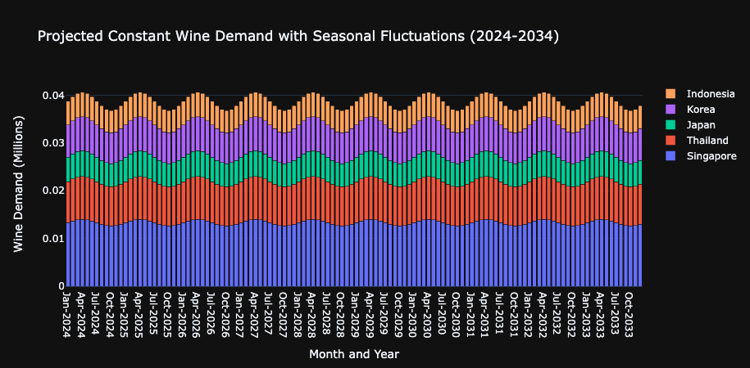

## Linear Demand

The demand for wine is projected to increase linearly, indicative of growing market penetration and customer base through the decade.

* The annual increase in demand is compounded, reflecting realistic market expansion goals.
* Initial demands for 2024 in millions
  + Singapore: 16 * 0.01
  + Thailand: 103 * 0.001
  + Japan: 615 * 0.0001
  + Kore: 814 * 0.0001
  + Indonesia': 59 * 0.001
* Projected demands for 2033 in millions (assuming steady growth rates)
  + Singapore: 16 * 1.4 * 0.01, (40% increase over the decade)
  + Thailand: 103 * 1.5 * 0.001, (50% increase over the decade)
  + Japan: 615 * 1.3 * 0.0001, (30% increase over the decade)
  + Korea: 814 * 1.2 * 0.0001, (20% increase over the decade)
  + Indonesia: 59 * 1.4 * 0.001 (40% increase over the decade)

### Implications

* Resource Planning: These demand forecasts are crucial for determining the number of oak barrels and tonnes of grapes required each year, ensuring we meet both immediate and future market needs effectively.
* Market Strategy: Understanding seasonal demand helps optimize the timing of wine releases to maximize sales and customer satisfaction.
* Expansion Strategy: The linear growth model informs our long-term resource allocation, facility expansion, and marketing efforts, aligning them with expected market developments.

## Customer Demand Satisfaction

It is crucial to note that the ability to meet customer demands for a specific wine depends fundamentally on the availability of the first batch of that wine. Demand satisfaction can only commence once the initial batch has completed the necessary production and aging processes and is fully prepared for market release. This initial availability sets the timeline for all subsequent demand fulfillment activities.

* Constant Demand
  + Simulation 1

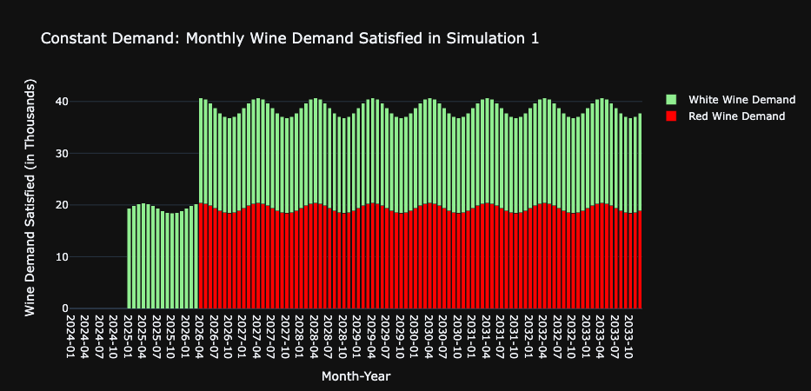

* + Simulation 2

* Linear Demand
  + Simulation 1

* + Simulation 2

## Optimized number of Oak Barrels for each wine per simulation

In the context of factory inventory management for winemaking, optimizing the number of oak barrels involves using simulation models to balance the aging needs of different wines with available barrel storage capacity, ensuring each varietal achieves its desired characteristics efficiently. Similarly, optimizing grape harvest volumes requires precise planning to align the yield with production capabilities and market demand, maximizing resource use and minimizing waste.

* Constant Demand
  + Simulation 1

* + Simulation 2

* Linear Demand (Increases over time)
  + Simulation 1

* + Simulation 2

## Optimized Grape Harvest Volumes

Optimized grape harvest volumes are strategically calculated to match the winery's processing capacity and storage availability, preventing overproduction, and minimizing waste. This approach ensures that each grape varietal is harvested at its optimal ripeness to maximize quality and efficiency in production.

* Constant Demand

* Linear Demand
  + Note: It's observed that the harvest volume for red grapes surpasses that of white grapes, which is attributed to the longer production time required for red wine; hence, the production of red wine is scheduled for a later time frame in comparison to white wine.

## Profit Analysis (at the end of 2034)

Profit analysis reveals that a linear demand model, which adjusts to market changes, typically yields better profits than a constant demand model, especially when expanding a winery to meet growing wine demand, as increased production, despite fixed costs like factory machines, can lead to greater long-term profitability.

* Constant Demand
  + Simulation 1

* + Simulation 2

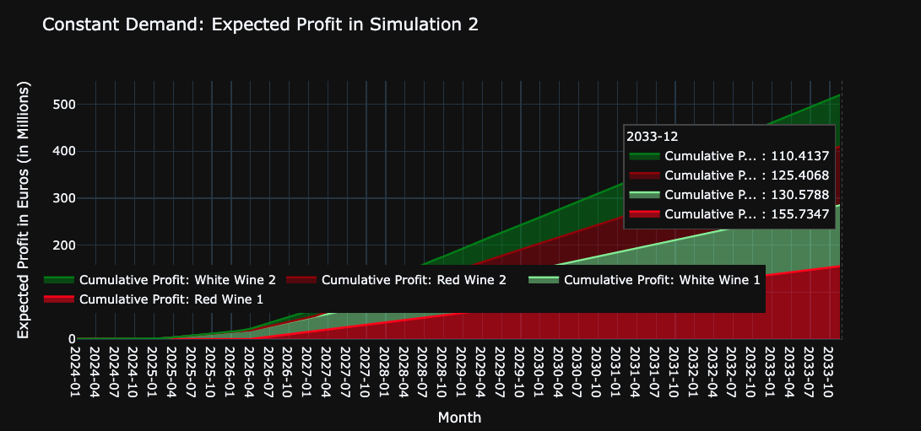

* Linear Demand
  + Simulation 1

* + Simulation 2

